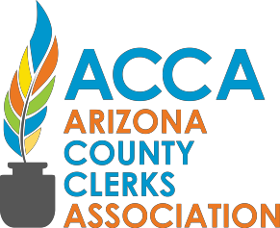

Arizona County Clerks Association

Executive Group

Virtual Business Meeting Agenda

February 9, 2022
1:00 P.M. Zoom Meeting

The Order of Items May Be Modified at The Meeting
CALL TO ORDER
ROLL CALL
ACTION ITEMS
- Approve Executive Group Minutes of February 4, 2021 – see attached
- Discussion and possible action to approve the Revision of Bylaws, as listed in Attachment A,
- Discussion and possible action regarding the Arizona County Clerks Association (ACCA) Certification Program Attachment B
DISCUSSION ITEMS
- Discussion of Corporation Commission Annual report and financial status of ACCA
- Discussion of Legislative Conference regarding new bills
ANNOUNCEMENTS
- County Announcements
ADJOURNMENT

